<http://www.fonts.com/content/learning/fontology/level-1/type-anatomy/type-classifications>

Classifications

**Serif Type Styles**

* Old Style

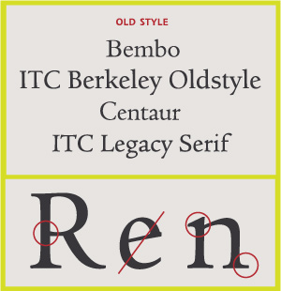

* Transitional

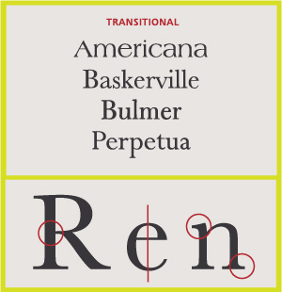

* Neoclassical & Didone

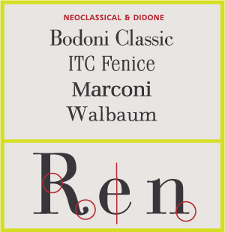

* Slab

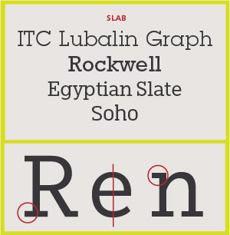

* Clarendon

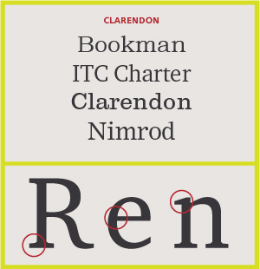

* Glyphic

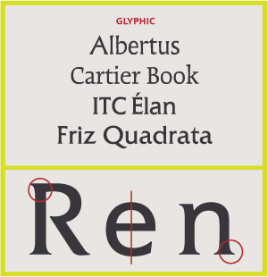

**Sans Serif Type Styles**

* Grotesque

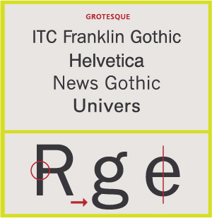

* Square
* Humanistic

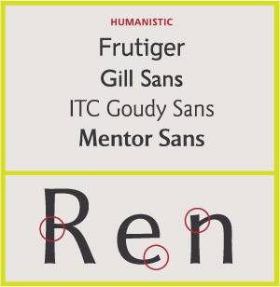

* Geometric

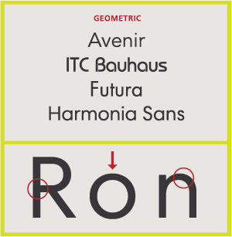

**Script Type Styles**

* Formal

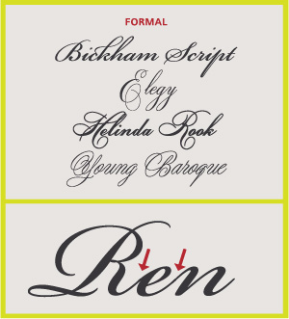

* Casual

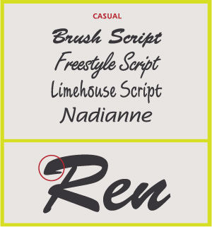

* Calligraphic

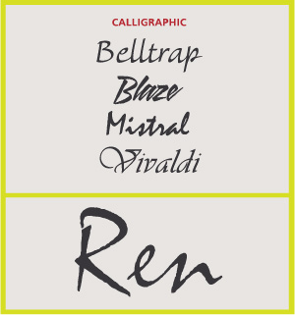

* Blackletter & Lombardic

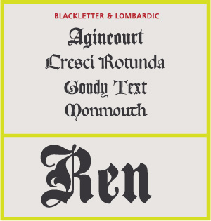

**Decorative**

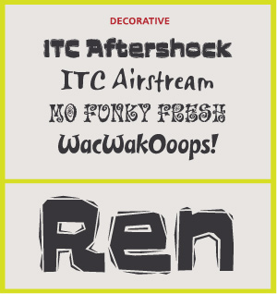

* Grunge
* Psychedelic
* Graffiti

Anatomy for interface design font:

(+detail)Display

Text

(-detail)Caption

Hyphen:- rose-colored

En dash:- 3-10’’

Em dash:--